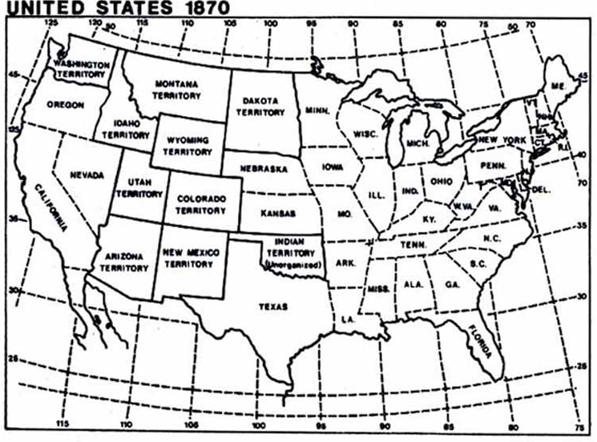

Westward Expansion Map
- Color the Great Plain states brown
- Label states that grew cotton - green (across the south - Arkansas, Mississippi, Alabama, Georgia, North & South Carolina)
- Label states that grew corn - yellow (Illinois & Nebraska)
- Color Texas purple & draw cattle trail from Texas to Missouri
- Label Birmingham, Alabama, as a part of the steel industry by drawing a red dot
- Color industrial areas in the North color blue
- Draw the Transcontinental Railroad
- Label states with Coal Mines with a black dot (WV, TN, KY)

