Unit 6A Study Guide

Settlers poured into western New York, Ohio, Michigan, Illinois, and Wisconsin. Good were transported at one-tenth the previous fee in less than half the previous time. Barge loads of farm produce and raw materials traveled east as manufactured goods and supplies flowed west. In nine years, tolls had paid back the cost of construction.

- Which construction project is being described in the passage?
- How would the construction of this canal help in the population growth of the west?
- What were the three parts to Henry Clay’s American System?
- What was the primary purpose of Henry Clay’s American System?
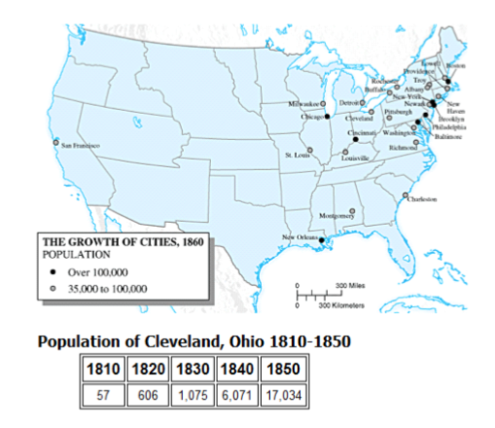
- Based on the map, explain the population growth that Cleveland experienced from 1810-1850.

Beginning in the 1820s, industrial ports in the Midwest like Madison, Indiana, grew. Madison became an important trading center for wool, cotton, flour, and lumber. Many other businesses grew to support the town and its population as it prospered. Crops and goods from other parts of Indiana made their way to Madison and were shipped to bigger markets along the Ohio and Mississippi Rivers, including Cincinnati, Pittsburgh, Louisville, and New Orleans.

- What technology, introduced in the early 1800s, was MOST important for the growth of towns like Madison, Indiana?

Extremely patriotic, Hire only US Citizens, Choose only Americans for Gov’t Jobs

- The list above describes what group of people?
Between 1820 and 1860, the Irish constituted over one third of all immigrants to the United States. In the 1840s, they compromised nearly half of all immigrants to the nation.

- What event led to an increase in Irish immigration during the 1840s?
- Where did most of the Irish settle when they arrived in the United States? Where did the Germans settle when they arrived in the United States?
- What did the temperance movement seek to stop? Why were women so commonly involved in this movement?
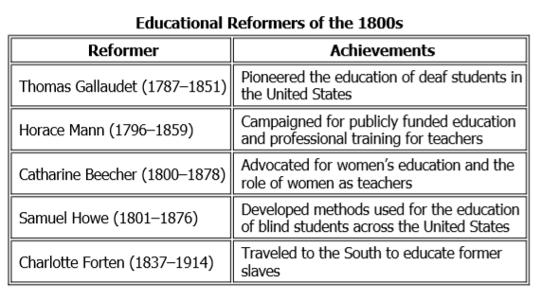
- For reformers such as Horace Mann, why was improving education so important?

At first the Mississippi seemed to recede from its banks, and its waters gathering up like a mountain, leaving for the moment many boats, which were here on their way to New Orleans, on bare sand, in which time the poor sailors made their escape from them. It then rising fifteen to twenty feet in perpendicularly, and expanding, as it were, the same moment, the banks were overflowed with retrograde (reverse) current, rapid as a torrent—the boats which before had been left on the sand were now torn from their moorings, and suddenly driven up a little creek, and the mouth of which they laid, to the distance in some instances, of nearly a quarter mile.

- According to the passage, what did the New Madrid Earthquake cause the Mississippi River to do?

During the early 19th century, reformers like Dorothea Dix worked to make prisons more humane. Dix, and others, supported the establishment of prison libraries, and literacy classes, fewer physical punishments, and shorter sentences. Reformers believed that a prison stay could help inmates to improve themselves.

- How did prison reform, supported by Dorothea Dix, affect life in the United States?

From the 1790s to the 1830s, a religious movement called the Second Great Awakening influenced American society. Baptists, Methodists, and Quakers were among the leading religious groups of this movement. Its message emphasized the idea of equality, which appealed to ordinary people and challenged elites. It also expressed a belief that people had the ability to make choices and act in ways that would improve themselves.

- How did the Second Great Awakening influence change in American society?
- List four reform movements that were sparked by the Second Great Awakening.

. . . there is no escape from the conclusion that she must be clothed with equal power to protect herself. That power is the ballot, the symbol of freedom and equality. . .

- Susan B. Anthony’s statement supporting the right to vote for women is based on what argument?
- What was the name of the meeting that called for better treatment of women?
- How were the Declaration of Rights and Sentiments and the Declaration of Independence Similar? Were these similarities intentional on the part of the delegates of the Seneca Falls Convention?
- What is transcendentalism? Who was the transcendentalist that lived out his philosophies by living at Walden Pond for two years, with only the bare necessities?
- What were four goals of the reformers in the various movements from 1820-1850?

