Unit 5 Study Guide
- Who was President of the United States during the War of 1812?
- What were the causes of the War of 1812? Which cause completes the diagram below?
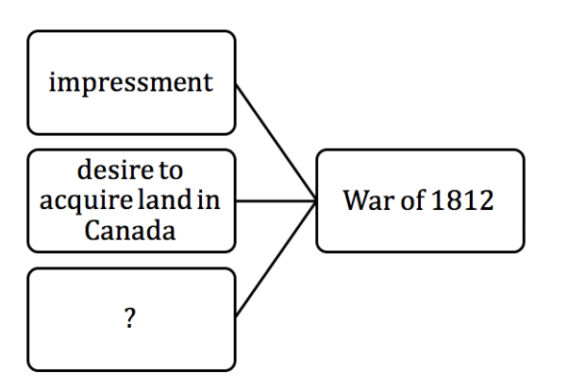
3. What does the practice of impressment have to do with?
4. Which politicians made a reputation as a War Hawk?
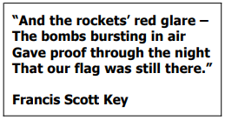
5. Which battle was the inspiration for the music lyrics above?
6. How did Tecumseh present a great threat to American expansion and settlement?
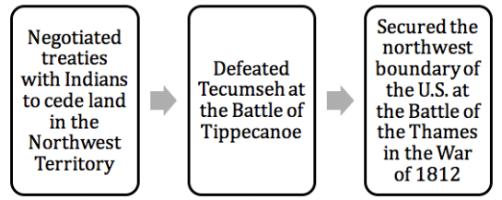
7. Who is described in the sequence above?
8. Which American leader led militia and frontiersmen to victory over the British at New Orleans in 1814?
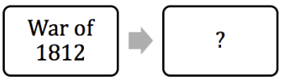
9. What outcomes complete the diagram above?
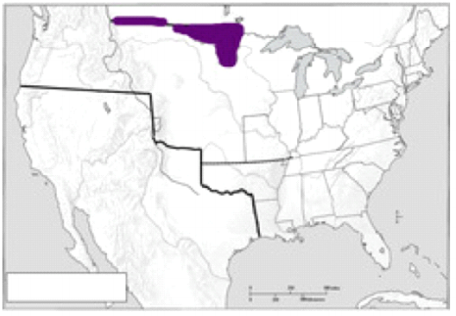
10. The territory shaded on the map was ceded to the United States through what?
11. Jackson’s actions in Florida helped the United States conclude which treaty with Spain?
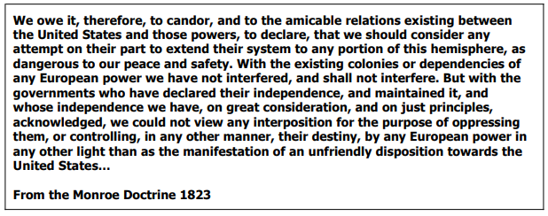
12. What conclusion can be drawn from the excerpt?
13. In addition to the assertions stated in the excerpt, the Monroe Doctrine also asserted that the United States would not do what?
14. Explain two causes of the War of 1812 and two effects of the War of 1812.

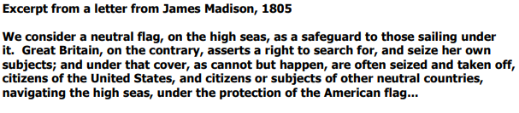
15. Does the passage above describe a cause of an effect of the War of 1812? What quote best proves this?
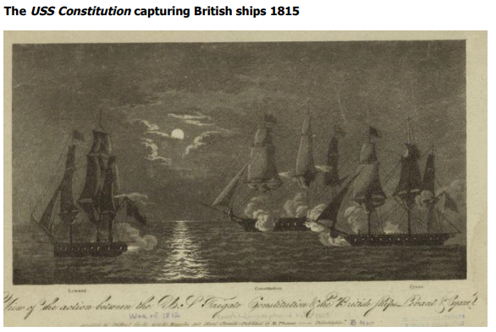
16. Does the picture show a cause or an effect of the War of 1812? Describe how you would use it to prove a cause or effect.
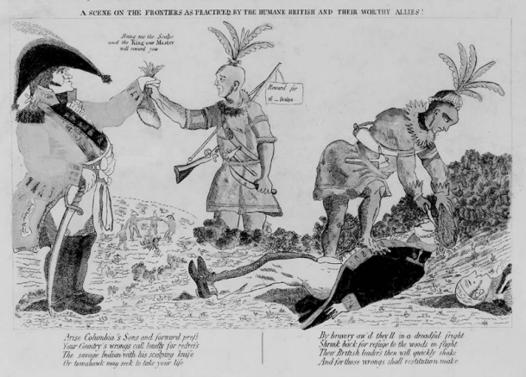
17. Does the picture show a cause of effect of the War of 1812? Describe how you would use it to prove a cause or effect.

