Unit 4 Study Guide
- Describe what the story of Rip Van Winkle is about. Where does this story take place? (What modern day state?) Why is this considered American Literature?
- Why novel did James Fenimore Cooper write? Describe what is was about. Why was James Fenimore Cooper a popular author among Europeans?
- What is the Natchez trace? Label the Natchez trace on the map
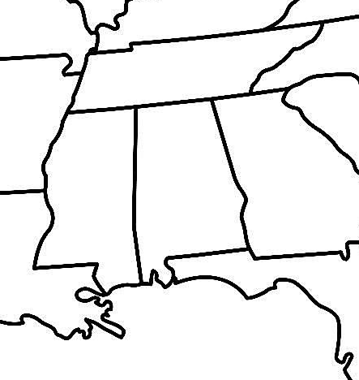
- What is the Jackson Purchase? Label the Jackson Purchase on the map below. What modern day city is included in the Jackson Purchase? Label it on the map.
- What was the Treaty of Holston? Why was it significant?
- What happened in the Election of 1800? Who were the candidates? Who won? Why was it significant?
“It is emphatically the province and duty of the judicial department to say what the law is.”
- What court case does this quote come from?
- What was the impact of the case (from #7)?
- Who was the Supreme Court Chief Justice for the case in #7?
- What happened in McCulloch v. Maryland? Why was it significant?
- What happened in Gibbons v. Ogden? Why was it significant?
- Overall, what was John Marshall’s impact on the power of the National Government?

- Describe the conflict between America and the Barbary states. What was the ultimate outcome? Illustrate how the war impacted America.

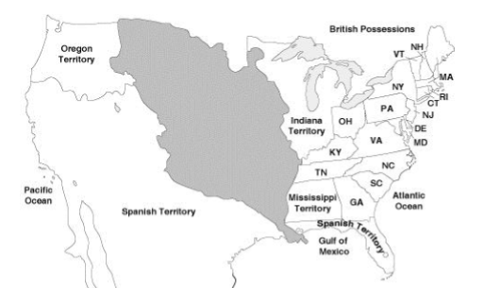
- What was the Louisiana Purchase? Label the Louisiana Territory on the map. What country did the US purchase the land from?
- What was an important impact of the Louisiana Purchase?
- Who did Jefferson send to explore the territory? How did the Louisiana Territory’s geography help them make their journey?
- List 2 purposes of the Lewis and Clark expedition.
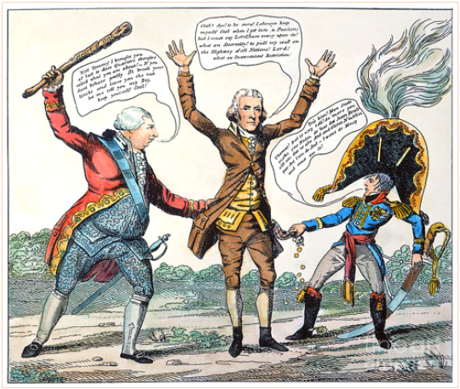
In the cartoon, President Jefferson is being threatened by Great Britain on one side and France on the other.
- Both the King and Napoleon are tugging on Jefferson’s pockets. Why?
- How did Jefferson respond to the conflict shown in the cartoon? What impact did this have on America?
- Who is John Sevier?
- Explain the following major accomplishments of Thomas Jefferson as President of the United States: Louisiana Purchase and the Embargo of 1807. Evaluate whether these accomplishments aligned with his view of strict construction of the Constitution or opposed that view. Use complete sentences.

