Unit 2 Study Guide
- What is New France? Where was it located? What did their economy depend on?
- Who created this political cartoon? What was the purpose of this political cartoon? (Your answer should include the name of the Plan and the purpose of the plan)
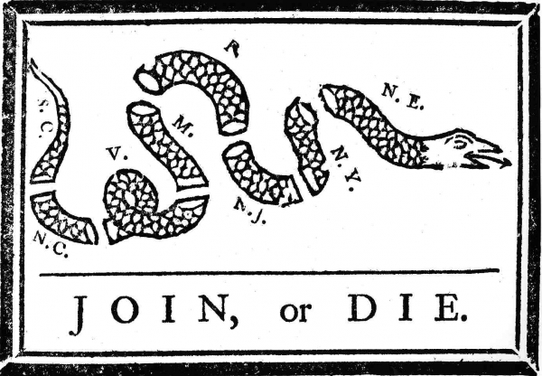
- What is the Wilderness Road? Where did it lead people to? Who helped create it?
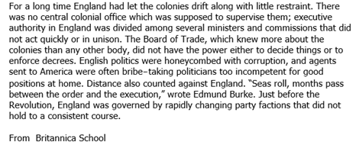
- What is salutary neglect? Find a quote in the passage that best demonstrates what salutary neglect is.
- Describe how salutary neglect impacted the governments of the various colonies.
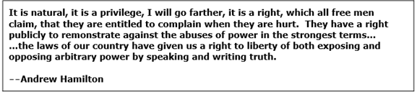
- What basic freedom is Andrew Hamilton arguing for? What trial did this quote come from?
- How did Britain win the French and Indian War, despite struggling early on in the war?
- What were the important effects (outcomes) of the French and Indian War?
- What is mercantilism? Create a diagram that represents mercantilism.
- What was the Proclamation of 1763? What was the purpose of it? Who benefited from it? Who was upset by it?
- What is “Common Sense”? Who wrote it? Who did he argue was the parent country of the colonies? What evidence did he give to prove this?
- Why do some consider the United States a “melting point”?
- What are the intolerable acts? Why were they created and what specifically did they do? How did they lead to the Revolutionary War?
- What happened at the battle of Saratoga? Why is it an important battle of the Revolutionary War?
- List all the ways that the French helped the colonists during the Revolutionary War. In what battle was their assistance most valuable?
- Who are the Wataugans? What present day state are they located in? Who did they fight during the Revolutionary War? Why did conflict with them increase during the War?
- Who are the Patriots? Where are they located? Who are the Loyalists? Where are they located?
- What is the Declaration of Independence? Who wrote it?
- Which Enlightenment thinker most influenced Thomas Jefferson in writing the Declaration of Independence?
- Who are the Sons of Liberty? How did they protest against Britain? What caused them to carry out the Boston Tea Party?
- Who is Marquis de LaFayette? How did he help the American colonists?
- Who is Baron von Steuben? How did he help the American colonists in the Revolutionary War?
- What are the 4 principles of the Declaration of Independence? What Enlightenment thinker influenced this document? Which principle did this person influence?

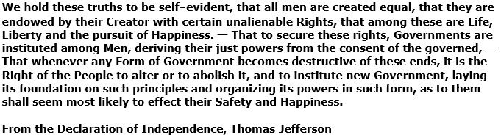
- Find a quote for each of the 4 principles in the Declaration of Independence. Rephrase and explain all 4 principles from the Declaration of Independence in modern language.

