1. The rise of the middle class most impacted English colonization through the

From The First Charter of Virginia, 1606

…that each of the said Colonies shall have a Council, which shall govern and order all Matters-and Causes…[and we declare] that all and every the Persons…which shall dwell and inhabit within every or any of the said several Colonies and Plantations, and every of their children…shall HAVE and enjoy all Liberties…as if they had been abiding and born, within this our Realm of England…”

2. Based on the excerpt, what can you come to understand about the rights of people in the colonies?

“This was that time, which still to this day we called the starving time; it were too vile to say, and scarce to be believed, what we endured: but the occasion was our own, for want [lack] of providence, industry and government, and not the barrenness and defect of the Country…”
-- John Smith, A History of Virginia

3. John Smith’s opinion about the reason for the “starving time” is what?

4. What role did John Rolfe play in the history of Jamestown?

5. What was the representative government in Jamestown?

6. Which contribution did Roger Williams make to the growth of democracy in the American colonies?

7. How did Anne Hutchinson challenge the authority of Puritan authorities in Massachusetts Bay?

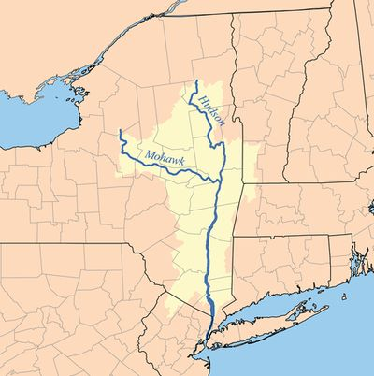
8. The area highlighted on the map was originally influenced by what culture? (Hint: you need to know what state this is)

9. Which feature contributed most to a high level of diversity in the population in the New York colony?

10. What were the major beliefs of the Quakers?

11. How did the Quakers view the Native Americans?

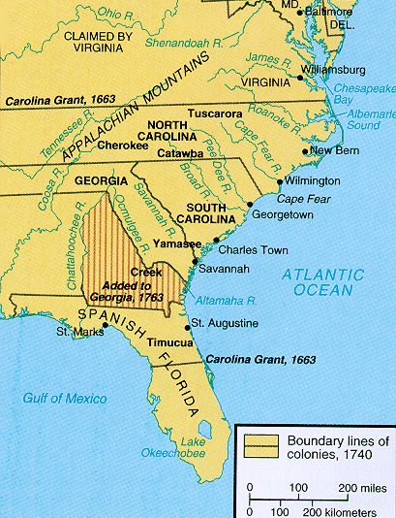

12. The map provides evidence of why Georgia was named the

13. Who founded the colony of Georgia?

14. What was the primary reason that this person (from #13) wanted to establish a colony?

Excerpts from speech by Canassatego, an Iroquois
“We know our lands are now become more valuable: the white people think we do not know their value; but we are sensible that the land is everlasting, and the few goods we receive for it are soon worn out and gone. Your people daily settle on these lands, and spoil our hunting…It is customary with us to make a present of skins whenever we renew our treaties. We are ashamed to offer our brethren so few; but your horses and cows have eat the grass our deer used to feed on.”
- The excerpt from Conassatego shows that Indians were primarily concerned with the:

- Which had the most devastating impact on Indian populations?

First, under European law, land was a commodity that could be bought and sold, and individuals who “owned” a tract of land had, for the most part, exclusive rights to its use. Second, ownership was determined by formal means, recognized by deeds and contracts and enforced by courts of law.

- Compared to the viewpoint described above, American Indians believed that land was what?

- Which effect completes the diagram? (What was the most important effect on the entire colonies?)

- Which of the following made the most important differences in the status of European settlers in different colonies?

“there shall be yearly two General Assemblies or Courts. . .the first shall be called the Court of Election, wherein shall be yearly chosen from time to time, so many Magistrates and other public Officers as shall be found requisite: Whereof one to be chosen Governor for the year ensuring and until another be chosen. . .”
--Fundamental Orders of Connecticut, 1639
20 . The excerpt above provides evidence that the early English colonists intended set up what kind of government?

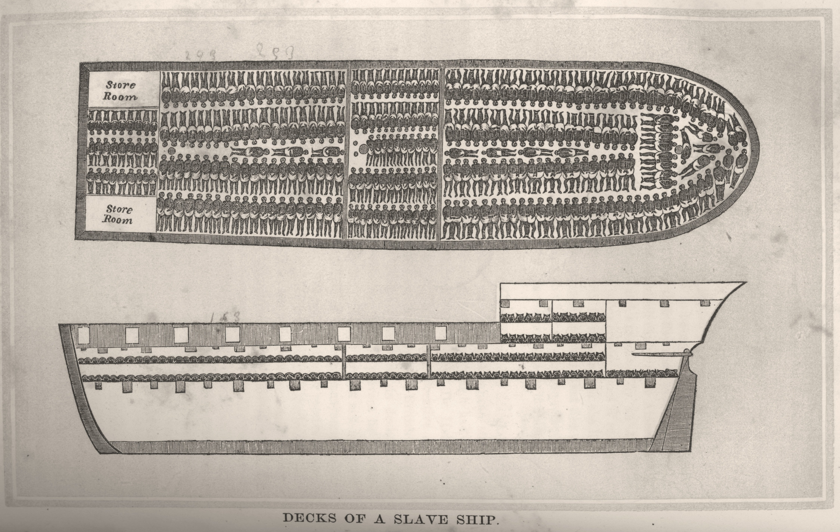

- The diagram above is most closely associated with which term?

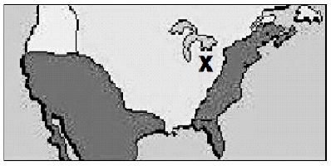
- Which country established fur trading posts in the area indicated by the X?

- Which reason best explains why France had trouble maintaining control of her colony, New France?
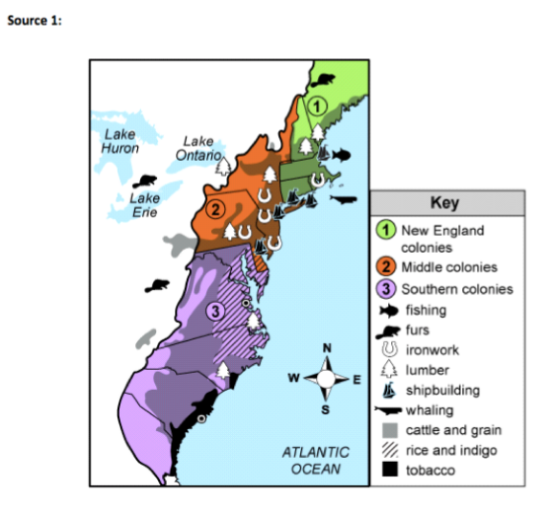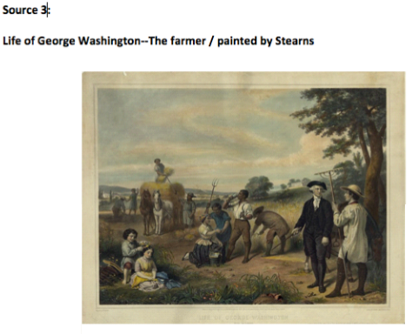
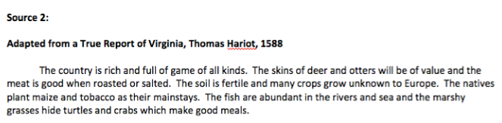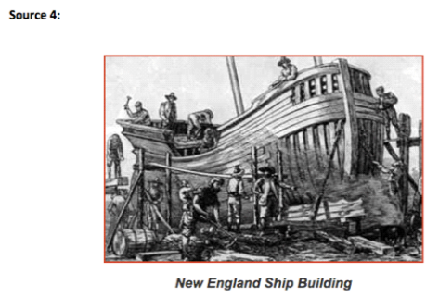

- Extended Response Question: Based on the provided sources and your background knowledge, describe how geography affected the cultural and economic development of the three distinct regions of the Thirteen Colonies. Use complete sentences and evidence to support your answer.

