Unit 10 Study Guide
- What did the economy (industry and agriculture) of the United States look like follow the Civil War? (What did each region do to make money?)
- What is a product of iron ore? Why is this important to industry?
- What is assimilation? How did this impact Native American life?
- Explain the significance of buffalo to Native Americans.
- What issues did buffalo pose to Railroad companies building across the Plains? How did they deal with this problem? How would that hurt Indians?
- Where did Native Americans score a major defeat over the US Army and George Custer?
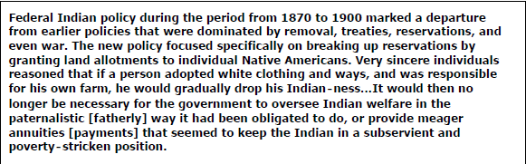
- What was the Dawes Act?
- Which sentence from the passage above defines assimilation?
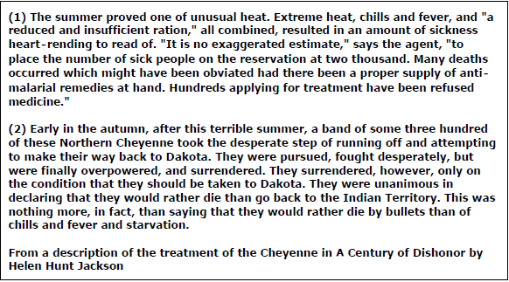
- What was Jackson’s purpose in writing A Century of Dishonor?
- Who the Sioux medicine man who resisted forced relocation?
- Who was the Nez Perce leader who surrendered to the US army?
- What was the Homestead Act? What were its major effects?
- What did homesteaders build their homes out of?
- What was the impact of major inventions like: barbed wire, windmill, steel plow, six shooter?
- What major obstacles would both the Central Pacific (building from California to the east) and Union Pacific (building from Nebraska to the west) have faced in constructing the Transcontinental Railroad?
- What were critical skills of cowboys?
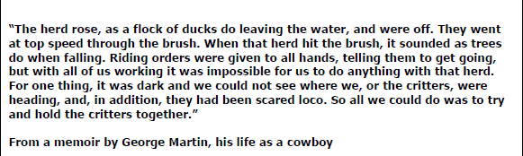
- What does the passage describe?
- What was the purpose of cowboys wearing chaps?
- What was the open range? What is the benefit?

