Perspectives of the Homefront

The following excerpt is from a letter written in 1862 by Mary W. Milling of South Carolina to her husband who is serving as a Confederate soldier during the American Civil War. Please read the excerpt, and answer the questions that follow:

“…Pa has had a severe attack of Typhoid fever--he is better now though not able to be out of bed yet--If he does not take a relapse I think he will recover now although he is very much reduced and it will take some time for him to regain his strength--There are a great many cases of the same fever on the plantation now, and has been for some time back--one death last Sunday night--a girl of twelve or thirteen years of age called Nelly--daughter of Patrick and Candace. Pa will be very backward with his crop in consequence of so much sickness and rainy weather
I do not know what are to become of us--it appears the Yankees will have complete possession of South Carolina before long--The people of Columbia and Charleston are very much afraid of those cities being shelled…They wrote that there was neither bacon nor molasses for sale in Charleston--What do you have to pay for Molasses? I thought you would be able to get them cheap out there and could feed the Negroes on them almost altogether--Molasses is selling at from 90 cts to $1 per gallon in Camden--bacon at 30cts—”

1. What is a main concern stated by Mrs. Milling in her letter?

2. What would cause “neither bacon nor molasses for sale in Charleston?”

3. Would you state that life during the war was more positive or negative for the author of the letter than before the war?

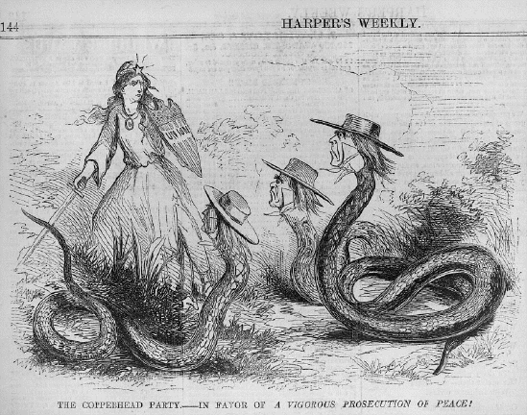

4. The picture shows Lady Liberty defending the Union against the “copperheads” whom are attacking her. What is the meaning of this cartoon? Should the Union be concerned with the position of “copperheads”?

5. Do you believe that “copperheads” should have been punished for their view on the Civil War? Why?

The following is a statement from a northern citizen arrested following President Lincoln’s suspension of certain individual rights during the Civil War. Read the letter and answer the questions that follow.

“All I did was speak out about how long the war was taking. I did not agree with the President in suspending our rights as citizens to speak freely in this nation. I was arrested and jailed without reason, and have been sitting in the cell for 50 days without seeing a judge. I believe it is time for me to have my day in court, and this abuse of justice must end.”

6. What action did President Lincoln perform that led to this individual’s arrest?

7. Do you support President Lincoln’s decision in this situation?

