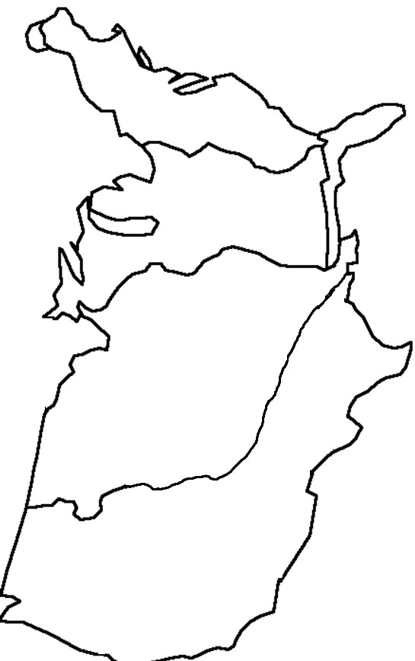
Louisiana Purchase Map
Directions: Use the maps on pages RA11 (Expanding West…Map), 276, 295, 303, 305, and 346 to fill in the map and answer the questions below.
Label or create the following bodies of water and water ways:
Mississippi River Atlantic Ocean
Missouri River Pacific Ocean
Ohio River Gulf of Mexico

Label the following cities:
New York City St. Louis
Boston Chicago
Philadelphia New Orleans
Memphis

Draw and label the following features:
Appalachian Mountains Rocky Mountains
Oregon Country New Spain

Color the Following:
United States in 1800 (orange) Louisiana Territory (green)
Oregon Country (red) Spanish Florida (blue)
New Spain (yellow)

Use page 303, 305 and 276 to draw and label the following:
Lewis and Clarks Expedition
Pike’s Expedition 1806-07

Questions:
- What city was the starting point for all westward exploration?

- List 2 purposes of the Lewis and Clark Expedition

- How did the Louisiana Territory's geography help them make their journey?

