Literature of Early America
Below is a summary of the story “Rip Van Winkle” by Washington Irving. Read it and answer the questions that follow.
Rip Van Winkle lives in a village in the Catskills (Appalachian Mountains in Southern New York) with his wife and children. He is an easygoing man with a nagging wife who constantly criticizes him. One day, Rip goes hunting in the mountains and meets Henry Hudson, the famous explorer who discovered the Hudson River. Rip eats and drinks with Hudson and his crew, then falls asleep under a tree.
Twenty years later, Rip Van Winkle wakes up to find that the world has changed. The American Revolution has occurred and America is its own nation. His wife has died. His kids are grown.
Eventually, Rip's daughter Judith accepts Rip as her father and brings him into her home. Judith has since grown up, married a man named Gardenier, and had a child. Everyone in the village soon changes their focus to the upcoming election of the President of the United States.
- What changes did the country go through in the 20 years that Rip Van Winkle was sleeping?

- Why would a story like this be considered “American Literature”?

Read the excerpt below and answer the questions that follow.
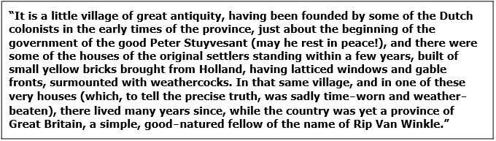
- What story does this come from? How do you know?

- What is being described in the passage?

- Who is Peter Stuyvesant?

- Who (What country/region) influenced the architecture and buildings of the village that are described?

- What present day state does the excerpt take place in? How do you know?

Last of the Mohicans
By: James Fenimore Cooper
The Last of the Mohicans is set in 1757, in what is now upstate New York near Saratoga Springs, during the French and Indian War. Hawkeye (the main character – a frontiersman, who grew up around Indians) try to help the British army escort two women to a fort. Hawkeye and his Indian friend encounter many difficulties in their journey through American wilderness. Their adventures and detail of the backcountry, interactions with Indians, are exciting to many Europeans who have never been to America and live in cities, with no interaction with the “savages” and “wilderness” seen in the United States.

- Who wrote “Last of the Mohicans”?

- What was it about?

- Why do you believe this story would’ve been popular?

Your Turn
Imagine you fell asleep and woke up twenty years from now. Write a narrative that describes the changes you predict you would see and how different America would be.

