King Andrew Assignment
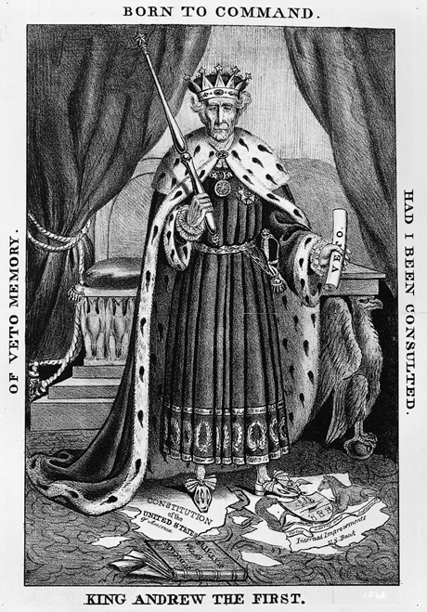
- Is this political cartoon positive or negative toward Andrew Jackson?

- What issues made people view Jackson in this way?

- What power does Jackson use that people are criticizing?

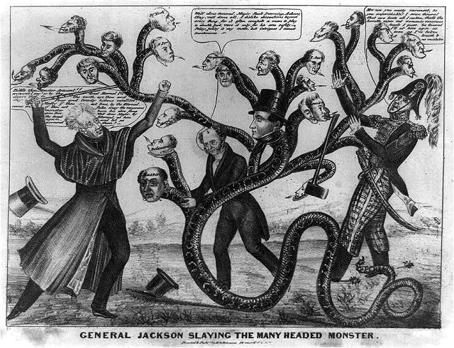
- Is this political cartoon positive or negative toward Andrew Jackson?

- Explain the point the political cartoon is making.

- Is either political cartoon accurate? Discuss why you feel this way.

- Now that we have discussed Jackson’s Presidency, do you believe he abused his power as president? Why or Why not?

