Jefferson DBQ
Read and analyze the documents – be sure to answer all of the questions.
- What are the different interpretations of the Constitution? Describe (with examples) what each interpretation is.
- What type of interpretation did Thomas Jefferson believe in? Why?
Document A:
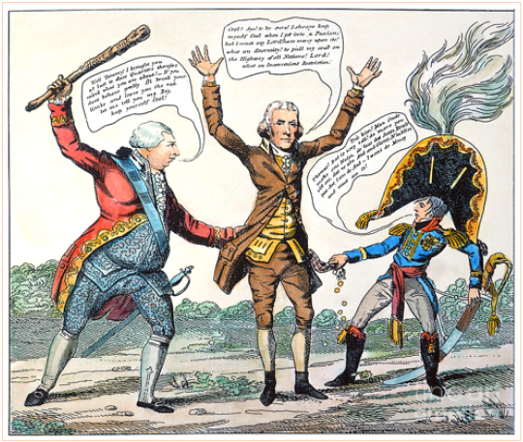
In the cartoon, President Jefferson is being threatened by Great Britain on one side and France on the other.
- What issue was America facing that this political cartoon refers to?
- Why are both the King and Napoleon tugging on Jefferson’s pockets?
- How does Jefferson respond to the issue?

Document B:
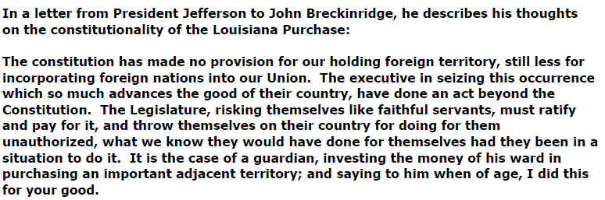
- Who wrote this letter? What is it about?
- Summarize the point that Jefferson is trying to make in this letter.
- How does this letter relate to Jefferson’s interpretation of the Constitution?
- What type of interpretation is Jefferson using? Find a quote that proves this.
- Using a quote, despite his beliefs, why does Jefferson still purchase the land of the Louisiana Purchase?
Document C:
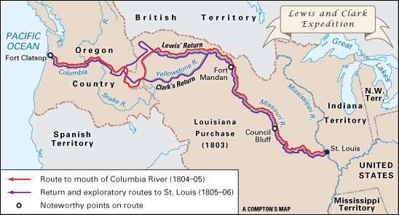
The Lewis and Clark expedition left its camp near St. Louis, Missouri, in May 1804, and arrived at the Pacific Ocean in November 1805.
- List 2 purposes of the Lewis and Clark expedition.
- How did the Louisiana Territory’s geography help Lewis and Clark make the journey?

Document D:
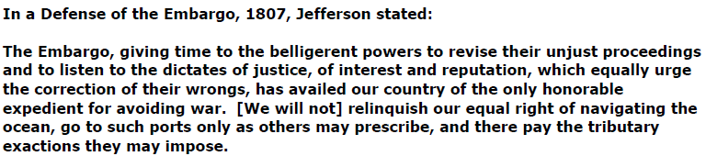
- What was the Embargo of 1807? Why was it created? - (Use a quote)
- What type of interpretation did Jefferson use to accomplish this?
Document E:
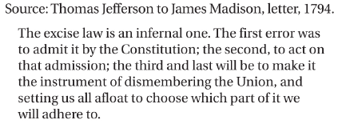

The quote above is about Hamilton’s Whiskey Tax during Washington’s Presidency.
- How would Jefferson feel when it comes to a Whiskey Tax?
- What does Jefferson predict will happen at the end of the quote?
Document F:
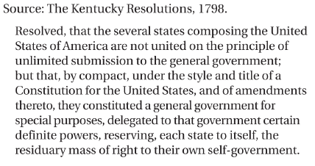
- What were the Kentucky and Virginia Resolutions in response to?
- When Jefferson discusses how all states had signed a “compact” – what is he referring to?
- What has happened that allows Jefferson to believe that states can nullify a National law?

Document G:
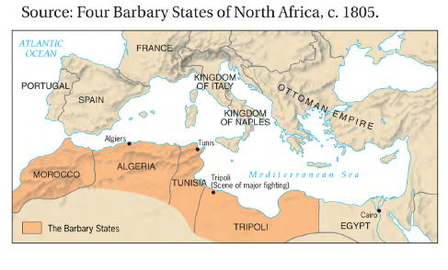
- Describe how the map above relates to Jefferson’s presidency.
- What was the ultimate outcome of American conflict with the Barbary states?
Document H:
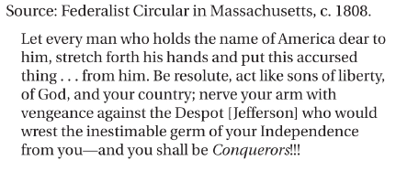
- What year does this quote come from?
- What event is this quote in response to? (Hint – consider the year)
- What group of people would have agreed with this quote?
- What is the speaker asking his audience to do? Why?
Extended Response:
- Use 4 of the provided sources and your own knowledge of Jefferson, explain TWO of the major accomplishments of Thomas Jefferson as President of the United States and evaluate whether these accomplishments aligned with his view of strict construction of the Constitution or opposed that view. Use complete sentences and evidence from the sources in your response.

