Evolution of Slavery in the United States Map
Slavery allowed = white and
Color in the areas that banned slavery, using a different color/pattern for each legislation/year
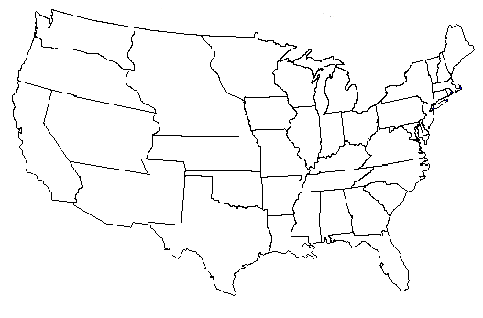
Key:
= Northwest Ordinance, 1787

