“Bleeding Kansas” Political Cartoon Assignment
Southern Chivalry: This is a political cartoon depicting Charles Sumner being beaten by Southern Congressman Preston Brooks after delivering an anti-slavery speech about bleeding Kansas. Fill in the speech bubbles with your own words (Remember: Sumner should be saying something against slavery and popular sovereignty while Preston Brooks should be saying something Pro-slavery or against Sumner’s speech

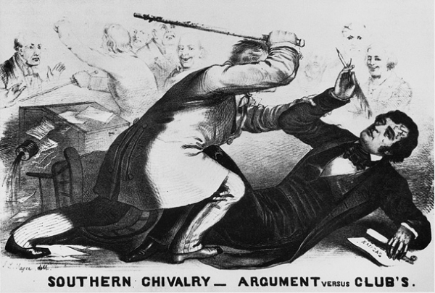
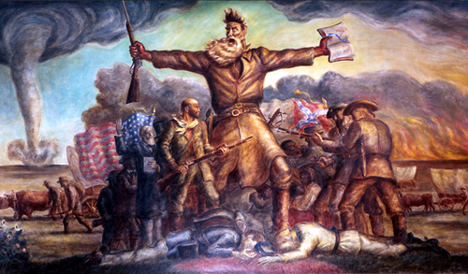
- What event is this picture referring to? Who is the Tall Man holding the gun and the book?

- What is this picture predicting? How do you know? (use examples from the picture)

