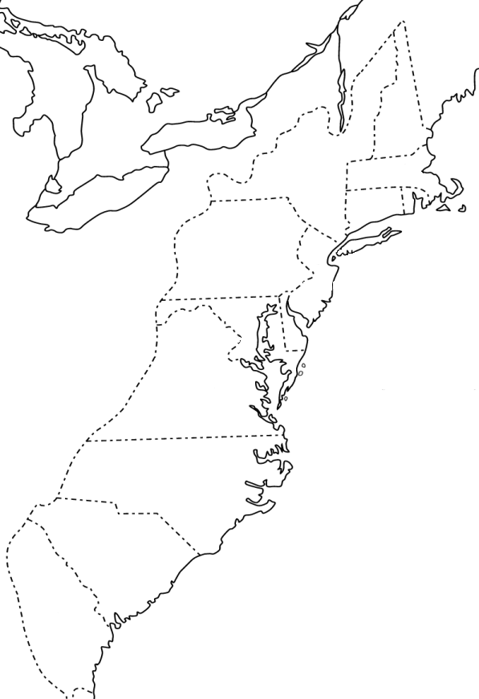
American Colonies Map
Label ALL 13 colonies:
Connecticut, Delaware, Georgia, Maryland, Massachusetts, New Hampshire, New Jersey, New York, North Carolina, Pennsylvania, Rhode Island, South Carolina, and Virginia
Label the following cities:
Boston Baltimore
New York Williamsburg
Salem Charles town
Philadelphia Savannah

Color the following regions in different colors using the maps on pages 67, 71, 76

New England Colonies
Middle Colonies
Southern Colonies

Answer the following questions using your notes and the maps on pages 67, 71 and 76

- List the common resources in the New England Colonies.
________________________________________________________________________________________________________________________________________________

- List the common resources in the Middle Colonies.
________________________________________________________________________________________________________________________________________________

- List the common resources in the Southern Colonies.
________________________________________________________________________________________________________________________________________________

- What was the area of the colonies that was less populated and at the foothills of the Appalachian Mountains? How did people survive there?
________________________________________________________________________________________________________________________________________________________________________________________________________________________________________________________________________________________________

